BUSINESS INSIGHT REPORT
Global Sales & Financial Performance
Student Name: [Enter Your Name]
Date: September 15, 2026

1. Introduction
This report presents a business insight analysis of the Global Sales & Financial Performance dataset, drawn from an interactive Power BI sales dashboard covering the period from 2018 to 2024. The purpose of this report is to interpret the dashboard's key performance indicators (KPIs) and visualizations, identify meaningful patterns in sales, profit, product, regional, and employee performance, and translate those findings into practical business recommendations. The analysis is intended to support decision-making around inventory planning, marketing strategy, regional expansion, workforce performance, product portfolio management, and customer targeting.

2. Dashboard Overview
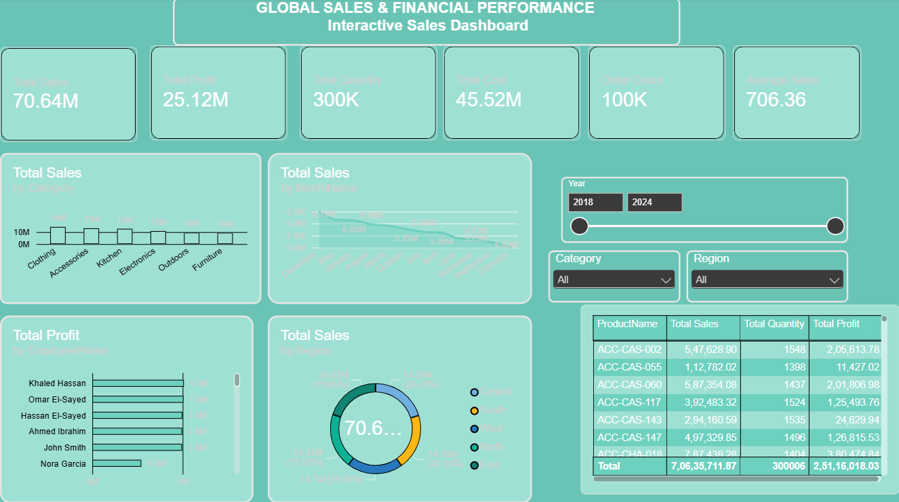
The Interactive Sales Dashboard consolidates the organization's global sales and financial performance into a single view. Along the top, six summary cards report the headline metrics: Total Sales, Total Profit, Total Quantity, Total Cost, Order Count, and Average Sales. Below the summary cards, the dashboard is organized into six panels: Total Sales by Category, Total Sales by Month Name, Total Profit by Employee Name, Total Sales by Region, a Year range slider with Category and Region filters, and a detailed product-level table listing Total Sales, Total Quantity, and Total Profit by Product Name. Together, these panels allow a user to filter the underlying data by year, category, and region, and to drill from a high-level financial summary down to individual product performance.

3. KPI Analysis
The dashboard's summary cards give an at-a-glance financial overview of the business over the 2018–2024 period:
KPI | Value
Total Sales | 70.64M
Total Profit | 25.12M
Total Quantity Sold | 300K units
Total Cost | 45.52M
Order Count | 100K orders
Average Sales per Order | 706.36

Total Profit of 25.12M against Total Sales of 70.64M implies an overall profit margin of roughly 35–36%, which is a healthy margin for a multi-category retail business. Total Cost of 45.52M accounts for the remaining share of revenue, confirming that cost of goods sold is the dominant driver of the sales-to-profit gap. With 100K orders generating 70.64M in sales, the Average Sales value of 706.36 per order indicates a moderate order value; the product-level table further shows that individual line items typically range from roughly 1,100 to 5,900 in sales, suggesting most orders bundle several items rather than a single high-ticket purchase.

4. Product Category Performance Analysis
The 'Total Sales by Category' panel breaks total revenue down across the seven product categories carried by the business: Clothing, Accessories, Kitchen, Electronics, Outdoors, and Furniture. The chart shows that sales are fairly evenly distributed across categories rather than being concentrated in one or two dominant lines, indicating a well-diversified product portfolio. This balance reduces the business's dependence on any single category, but it also means no single category is currently acting as a standout growth driver. In the product-level detail table, several of the top individual SKUs by sales and profit belong to the Accessories (ACC-CAS-*) and Chairs/Furniture (ACC-CHA-*) sub-lines, with ACC-CHA-018 and ACC-CAS-060 among the strongest performers by both sales and profit contribution.

5. Monthly Sales Trend Analysis
The 'Total Sales by Month Name' line chart tracks revenue across the calendar months. The trend line is relatively flat with a gentle downward drift across most of the year, moving from the mid-6M range in the earlier months toward the high-5M range later on, rather than showing a single sharp seasonal peak. This suggests demand is fairly stable month to month, with only modest seasonal variation. The absence of a pronounced peak season indicates an opportunity: introducing seasonal promotions or bundling offers during the historically softer months could help smooth out and lift the monthly trend rather than relying on organic demand alone.

6. Regional Sales Analysis
The 'Total Sales by Region' donut chart splits total revenue across five regions: Central, South, West, North, and East. The distribution across regions is close to even, with each region contributing roughly one-fifth of total sales, and no single region dominating the overall mix. This even geographic spread suggests the business has achieved broad market coverage rather than being dependent on one core region. At the same time, because no region is significantly ahead, each region likely still has untapped headroom, and the more moderately performing regions represent the clearest targets for focused regional expansion or localized marketing investment.

7. Employee Performance Analysis
The 'Total Profit by Employee Name' bar chart ranks employees by the profit they have generated. Khaled Hassan leads the ranking, followed closely by Omar El-Sayed and Hassan El-Sayed, with Ahmed Ibrahim and John Smith contributing at a moderately lower but still substantial level. Nora Garcia sits noticeably below the rest of the team. This spread indicates a performance gap between the top three contributors and the remaining staff, particularly the lowest performer, and points to an opportunity for targeted coaching, mentoring from top performers, or a review of account/territory assignments to help close the gap.

8. Product-Level Detail (Top Records)
The table below reflects a sample of the product-level records and grand totals shown in the dashboard's detail table:
Product Name | Total Sales | Total Quantity | Total Profit
ACC-CAS-002 | 5,47,628.90 | 1,548 | 2,05,613.78
ACC-CAS-055 | 1,12,782.02 | 1,398 | 11,427.02
ACC-CAS-060 | 5,87,354.08 | 1,437 | 2,01,806.98
ACC-CAS-117 | 3,92,483.32 | 1,524 | 1,25,493.76
ACC-CAS-143 | 2,94,160.59 | 1,535 | 24,629.94
ACC-CAS-147 | 4,97,329.76 | 1,496 | 1,26,815.53
ACC-CHA-018 | 7,87,438.28 | 1,404 | 3,80,474.84
Total (All Products) | 7,06,35,711.87 | 3,00,006 | 2,51,16,018.03

9. Business Recommendations

Inventory Planning
- Align stock levels with the relatively flat monthly demand pattern rather than over-provisioning for a single peak season; maintain steady base inventory with small, targeted buffers ahead of promotional periods.
- Prioritize replenishment for consistently strong SKUs such as ACC-CHA-018 and ACC-CAS-060, while auditing lower-turnover items like ACC-CAS-055, which shows comparatively low profit relative to its sales.

Marketing Strategy
- Launch promotions or bundles during the softer months identified in the monthly trend to lift sales during naturally quieter periods.
- Use category-level parity as a cross-sell opportunity: bundle complementary items across Kitchen, Outdoors, and Furniture to raise average order value beyond the current 706.36.

Regional Expansion
- Since sales are evenly spread across Central, South, West, North, and East, invest in the regions with the most headroom relative to their market potential, using local campaigns to convert the even baseline into clearer regional leaders.
- Pilot region-specific assortments or pricing in the currently mid-performing regions to test whether targeted investment can lift their share of total sales.

Employee Performance
- Pair lower-performing staff, such as Nora Garcia, with top performers like Khaled Hassan and Omar El-Sayed through structured mentoring or shadowing.
- Review territory, account, or category assignments across the team to ensure the performance gap reflects genuine effort differences rather than uneven opportunity.

Product Portfolio
- Continue supporting the balanced category mix, but evaluate whether Clothing and Accessories, which include several top individual SKUs, warrant additional shelf space or marketing spend given their consistent profit contribution.
- Reassess low-margin SKUs such as ACC-CAS-055, where profit is small relative to sales, to determine whether pricing, cost, or promotional discounting is compressing margin.

Customer Targeting
- Use the fairly uniform Average Sales value across orders to design tiered loyalty offers that reward customers who push their order value above the 706.36 average.
- Segment customers by category preference and region to enable more personalized offers, building on the categorical and regional data already captured in the dashboard.

